1. **DESCRIPTION OF THE COMPANY**

TÜBİTAK-SAGE (The Scientific and Technological Research Council of Turkey – Defense Industries Research and Development Instute) was established in 1972, and is active at Lalahan Site which is 30 km away from the city center of Ankara.

The main function of SAGE is to perform research and development activities for defense systems including engineering and prototype production, starting with their fundamental research and conceptual design. Most of the projects are performed in coordination with related defense institutions.

SAGE believes international cooperation is as important as national partnerships and wishes to exchange knowledge with various partners from allied countries.

In SAGE, there are 425 personnel, 264 of them are engineer.

TUBİTAK SAGE produce only prototypes, serial production is when prototype pass from quality control.

*Organization Chart*

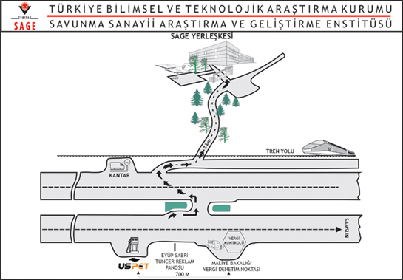

*Location Plan*

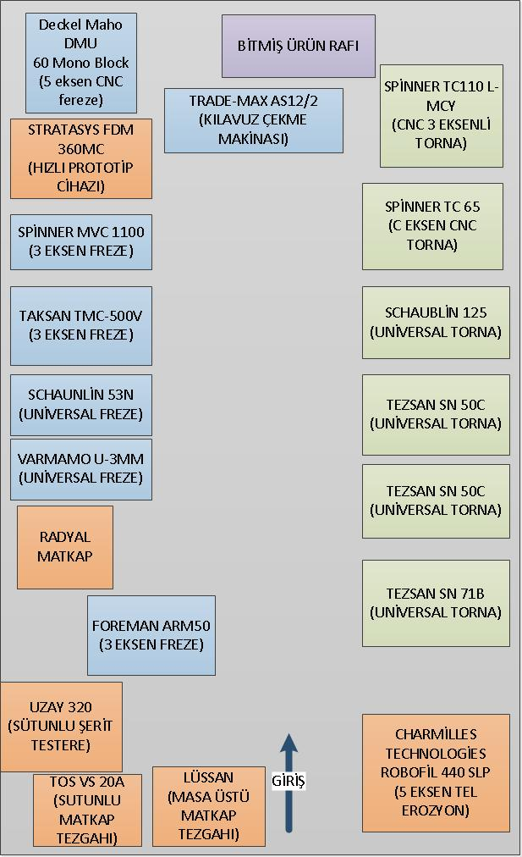

**2. INTRODUCTION**

In today’s developing societies, human being is always coming after new technologic researches and developments. Every new development requires high engineering knowledge and applications that are carried on day by day. Like every country, Turkey needs to follow these developments on time and make sure that it compensates the sociologic needs. Only way to be successful and competent in this area is giving the necessary importance to science and engineering education, affording the researches and its equipments.

Mechanical Engineering is the most comprehensive one of all engineering professions. Therefore the theoretical and practical knowledge given to mechanical engineering students during the 4-year education period is not enough to be a good engineer.

Summer practices provide good opportunities to make students see the application areas of the theoretical knowledge and learning the basic machines which are being used in industry and manufacturing. It is very important to learn all the needed information about the machines, measuring and smoothing techniques. One another the important point is to practise all these concepts individually.

Being a good mechanical engineer, some other features are required, such as; researching, planning, having good dialogue with people, finding practical solutions for the problems, etc. This features are mostly gained by the personal effort rather than the knowledge from school. So the summer training period has an important part of this engineering experiences.

Also the student learns the life of labor in this practise. Observing the engineers and technicians finds out the engineering problems and how to solve them.

This is the report for the mechanical engineering first summer practise outside the school. In my report the basic machines of the manufacturing and the industry are being introduced. To get the informations and the practices on the each machine, six weeks were spent. At the end usages, properties and the importance of these machines were understood well. Some additional and extra work is also done to realise the function of the engineers.

I want to mention about my daily routine during the practice.

* 8:30-12:30..........working time
* 12:30-13:30..........lunch
* 13:30-17:30……..working time

1. **PRODUCTION**
   1. **CUTTING AND BENDING** 
      1. ***Turning***

Turning is the machining operation that produces cylindrical parts. In its basic form, it can be defined as the machining of an external surface:

- with the workpiece rotating,

- with a single-point cutting tool, and

- with the cutting tool feeding parallel to the axis of the workpiece and at a distance that will remove the outer surface of the work.

Taper turning is practically the same, except that the cutter path is at an angle to the work axis. Similarly, in contour turning, the distance of the cutter from the work axis is varied to produce the desired shape.

Even though a single-point tool is specified, this does not exclude multiple-tool setups, which are often employed in turning. In such setups, each tool operates independently as a single-point cutter.

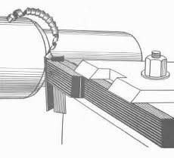

*(turning operation)*

The three primary factors in any basic turning operation are speed, feed, and depth of cut. Other factors such as kind of material and type of tool have a large influence, of course, but these three are the ones the operator can change by adjusting the controls, right at the machine.

Speed, always refers to the spindle and the workpiece. When it is stated in revolutions per minute it tells their rotating speed. But the important figure for a particular turning operation is the surface speed, or the speed at which the workpiece material is moving past the cutting tool. It is simply the product of the rotating speed times the circumference of the workpiece before the cut is started. It is expressed in surface feet per minute, and it refers only to the workpiece. Every different diameter on a workpiece will have a different cutting speed, even though the rotating speed remains the same.

Feed, always refers to the cutting tool, and it is the rate at which the tool advances along its cutting path. On most power-fed lathes, the feed rate is directly related to the spindle speed and is expressed in inches per revolution of the spindle.

Depth of Cut, is practically self explanatory. It is the thickness of the layer being removed from the workpiece or the distance from the uncut surface of the work to the cut surface, expressed in inches. It is important to note, though, that the diameter of the workpiece is reduced by two times the depth of cut because this layer is being removed from both sides of the world.

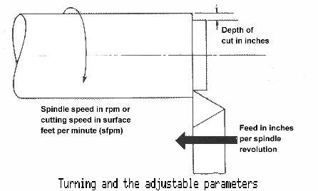

## 

## Installing a Cutting Tool

Lathe cutting tools are held by tool holders. To install a tool, first clean the holder, then tighten the bolts. The tool post is secured to the compound with a T-bolt. The tool holder is secured to the tool post using a quick release lever. 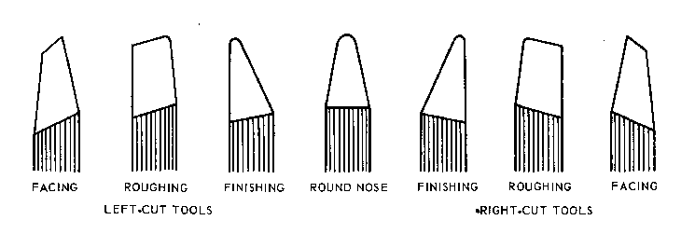  
*Figure 6 ( some types of cutting tool )*

Besides that, turning machines can be grouped into two main section.

Universal Turning Machines: The most usefull and easy one, it is very appropriate for non-serial operations.

Special Turning Machines: It has six sub groups :

* + - Air Turning Machines: This is used to operate on the very big diameter pieces. Some parts are separated from each other as it is a very big machine.
    - Vertical Turning Machines: It is used to operate on the very heavy parts. These parts rotate around a vertical pressure better than the others.
    - Copying Turning Machines: It is used to copy the machine parts according to an original profile.
    - Revolver Turning Machines: It is a semi-automatic machine that can go over many serial operations. On there volver head of the machine, we put some cutting parts and they execute the needed operation in an order during rotation.
    - Automated (index) Turning Machines: It makes all the required operations by itself. Once it is adjusted and calibrated, it repeats the same processes on identical parts. It is usually used for small and standard parts.
    - CNC Turning Machines: CNC stands for “computer numerical control”. The computer loaded with the needed software and picture leads the operation.

The headstock contains the drive mechanism, usually in corporating change gears and/or a variable-speed drive. Long workpieces are supported at their end with a center held in the tailstock. The tool itself is held in a tool post which allows setting the tool at an angle.

The tool post is mounted on a cross slide which provides radial tool movement. The cross slide is guided in a carriage, which in turn received support from the ways machined in the bed that ensure rigidity and freedom from vibration. An overhanging part, the apron of the carriage, may be engaged with the feed rod to give continuous feed motion, or with a lead screw for the cutting of threads. Very long workpeaces are secured against excessive deflection by two fingers of a center rest or steady rest bolted to the lathe bed; a follow rest is clamped to the carriage.

Sometimes the tool post sits on a compound tool rest which incorporates a slide that can be set at any angle, conical surface may be formed by hand feeding the tool. A four-way tool post can be rotated about a vertical shaft and allows quick changing of tools in present position, thus speeding up successive operations.

The lathe can be used to reduce the diameter of a part to a desired dimension. First, clamp the part securely in a lathe chuck. The part should not extend more that three times its diameter. Then install a roughing or finishing tool (whichever is appropriate). If you're feeding the saddle toward the headstock (as in the clip below) use a right-hand turning tool. Move the tool off the part by backing the carriage up with the carriage handwheel, then use the cross feed to set the desired depth of cut. In the clip below, a finish cut is made using the power feed for a smoother finish. Remember that for each thousandth depth of cut, the work diameter is reduced by two thousandths.

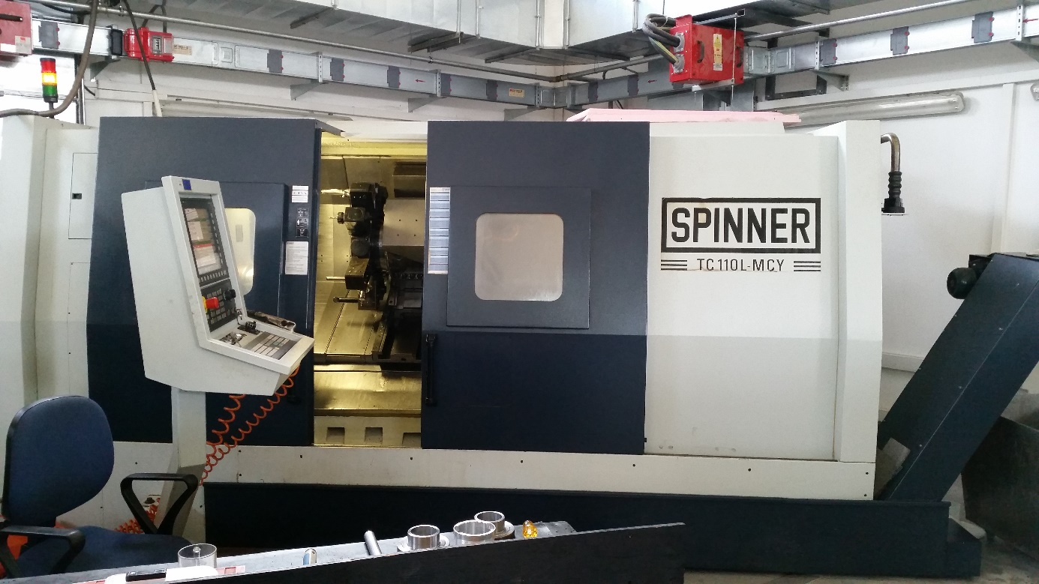

* + 1. ***Drilling***

A lathe can also be used to drill holes accurately concentric with the centerline of a cylindrical part. First, install a drill chuck into the tail stock. Make certain that the tang on the back of the drill chuck seats properly in the tail stock. Withdraw the jaws of the chuck and tap the chuck in place with a soft hammer. Move the saddle forward to make room for the tailstock. Move the tailstock into position, and lock the it in place (otherwise it will slide backward as you try to drill). Before starting the machine, turn the spindle by hand. You've just moved the saddle forward, so it could interfere with the rotation of the lathe chuck. Always use a centerdrill to start the hole.

Drilling is easily the most common machining process. Drilling involves the creation of holes that are right circular cylinders. This is accomplished most typically by using a twist drill.

The chips must exit through the flutes to the outside of the tool. As can be seen in the figure, the cutting front is embedded within the workpiece, making cooling difficult. The cutting area can be flooded, coolant spray mist can be applied, or coolant can be delivered through the drill bit shaft.

The workpiece is held in place by a C-clamp since cutting forces can be quite large. It is dangerous to hold a workpiece by hand during drilling since cutting forces can unpredictably get quite large and wrench the part away. Wood is often used underneath the part so that the drill bit can overshoot without damaging the table. The table also has holes for drill overshoot as well as weight reduction. A three-jaw chuck is used since three points determine a circle in two dimensions. Four-jaw chucks are rarely seen since offset of the bit is not necessary.

* + 1. ***Facing***

Facing is the producing of a flat surface as the result of a tool's being fed across the end of the rotating workpiece. Unless the work is held on a mandrel, if both ends of the work are to be faced, it must be turned end for end after the first end is completed and the facing operation repeated. The cutting speed should be determined from the largest diameter of the surface to be faced. Facing may be done either from the outside inward or from the center outward. In either case, the point of the tool must be set exactly at the height of the center of rotation. because the cutting force tends to push the tool away from the work, it is usually desirable to clamp the carriage to the lathe bed during each facing cut to prevent it from moving slightly and thus producing a surface that is not flat. In the facing of casting or other materials that have a hard surface, the depth of the first cut should be sufficient to penetrate the hard material to avoid excessive tool wear.

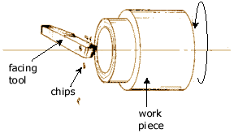

*(facing operation)*

* + 1. ***Boring***

Boring always involves the enlarging of an existing hole, which may have been made by a drill or may be the result of a core in a casting. An equally important and concurrent purpose of boring may be to make the hole concentric with the axis of rotation of the workpiece and thus correct any eccentricity that may have resulted from the drill drifting off the centerline. Concentricity is an important attribute of bored holes.

When boring is done in a lathe, the work is usually held in a chuck or on a faceplate. Holes may be bored straight, tapered or to irregular contours. Several machines have been developed that are specially adapted to boring work. One of them, known as a jig borer is constructed for precision work on jig and fixtures similar in appearance to a drill press, it will do both drilling and end-milling work in addition to boring . The vertical boring mill and the horizontal boring machine are adapted to large work. Although the operations that these machines perform can be done on lathes and other machine, their construction is justified by the easily, economically obtained in holding and machining the work.

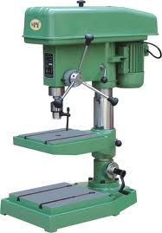

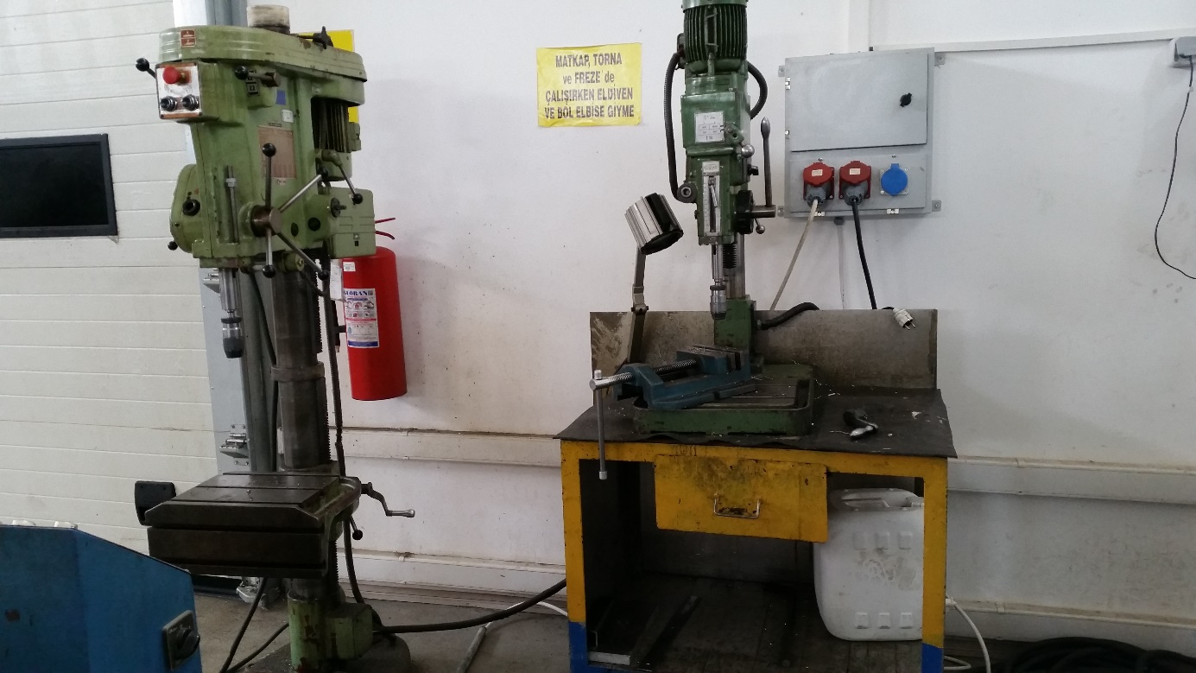

*(boring machine)*

* + 1. ***Parting***

Parting is the operation by which one section of a workpiece is severed from the remainder by means of a cut off tool. Because cutting tools are quite thin and must have considerable overhang, this process is less accurate and more difficult. The tool should be set exactly at the height of the axis of rotation, be kept sharp, have proper clearance angles, and be fed into the workpiece at a proper and uniform feed rate.

* + 1. ***Grinding***

Grinding is a finishing process used to improve surface finish, abrade hard materials, and tighten the tolerance on flat and cylindrical surfaces by removing a small amount of material.

In grinding, an abrasive material rubs against the metal part and removes tiny pieces of material. The abrasive material is typically on the surface of a wheel or belt and abrades material in a way similar to sanding. On a microscopic scale, the chip formation in grinding is the same as that found in other machining processes. The abrasive action of grinding generates excessive heat so that flooding of the cutting area with fluid is necessary. Reason for grinding is that the material is too hard to be machined economically.

Tolerances required preclude machining. Grinding can produce flatness tolerances of less than ±0.0025 mm (±0.0001 in) on a 127 x 127 mm (5 x 5 in) steel surface if the surface is adequately supported.

* + 1. ***CNC Wire Erosion***
* Support Stroke: 400*250*200
* Size Of Support: 800 (+)*500
* Required Electric Power: 10 kW
* Wire Thickness: 0.25mm
* Wire Material: Generaly Copper, but sometimes Brass.
* Software: It works with Cammand.
* Working Condition: Room temperature must be 20 Ċ .
* Cooling Liquid: Water.Because it conducts electric.
* It works on two axis. (X-Y)
* Working Principle: Wire is catode, table is anode and product settle on table . Then arc is created between wire and product.
* Products which are material hardened with higher temperature are produced.
* Machine cannot make new hole on the product.But it enlarges old holes on the product.

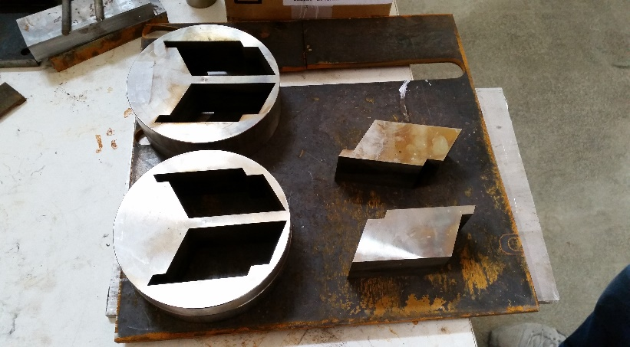

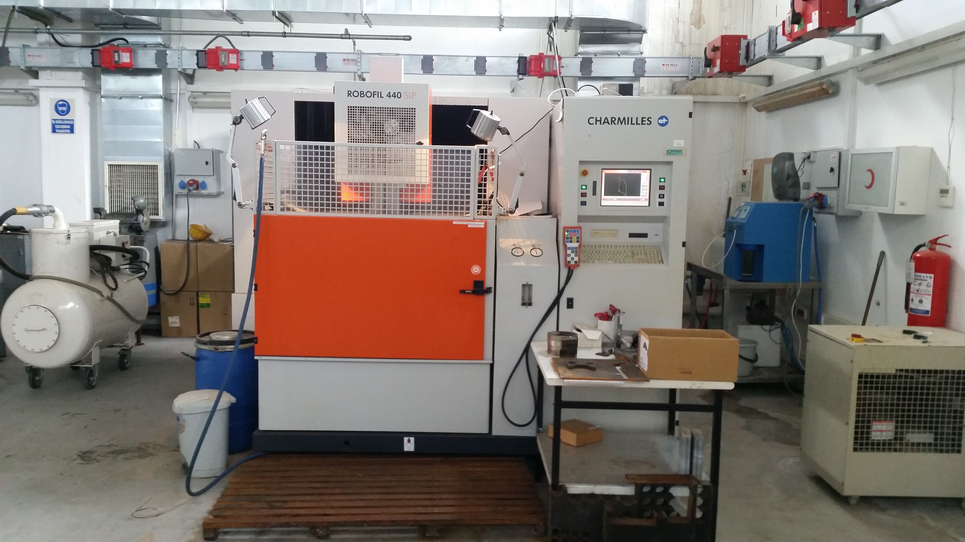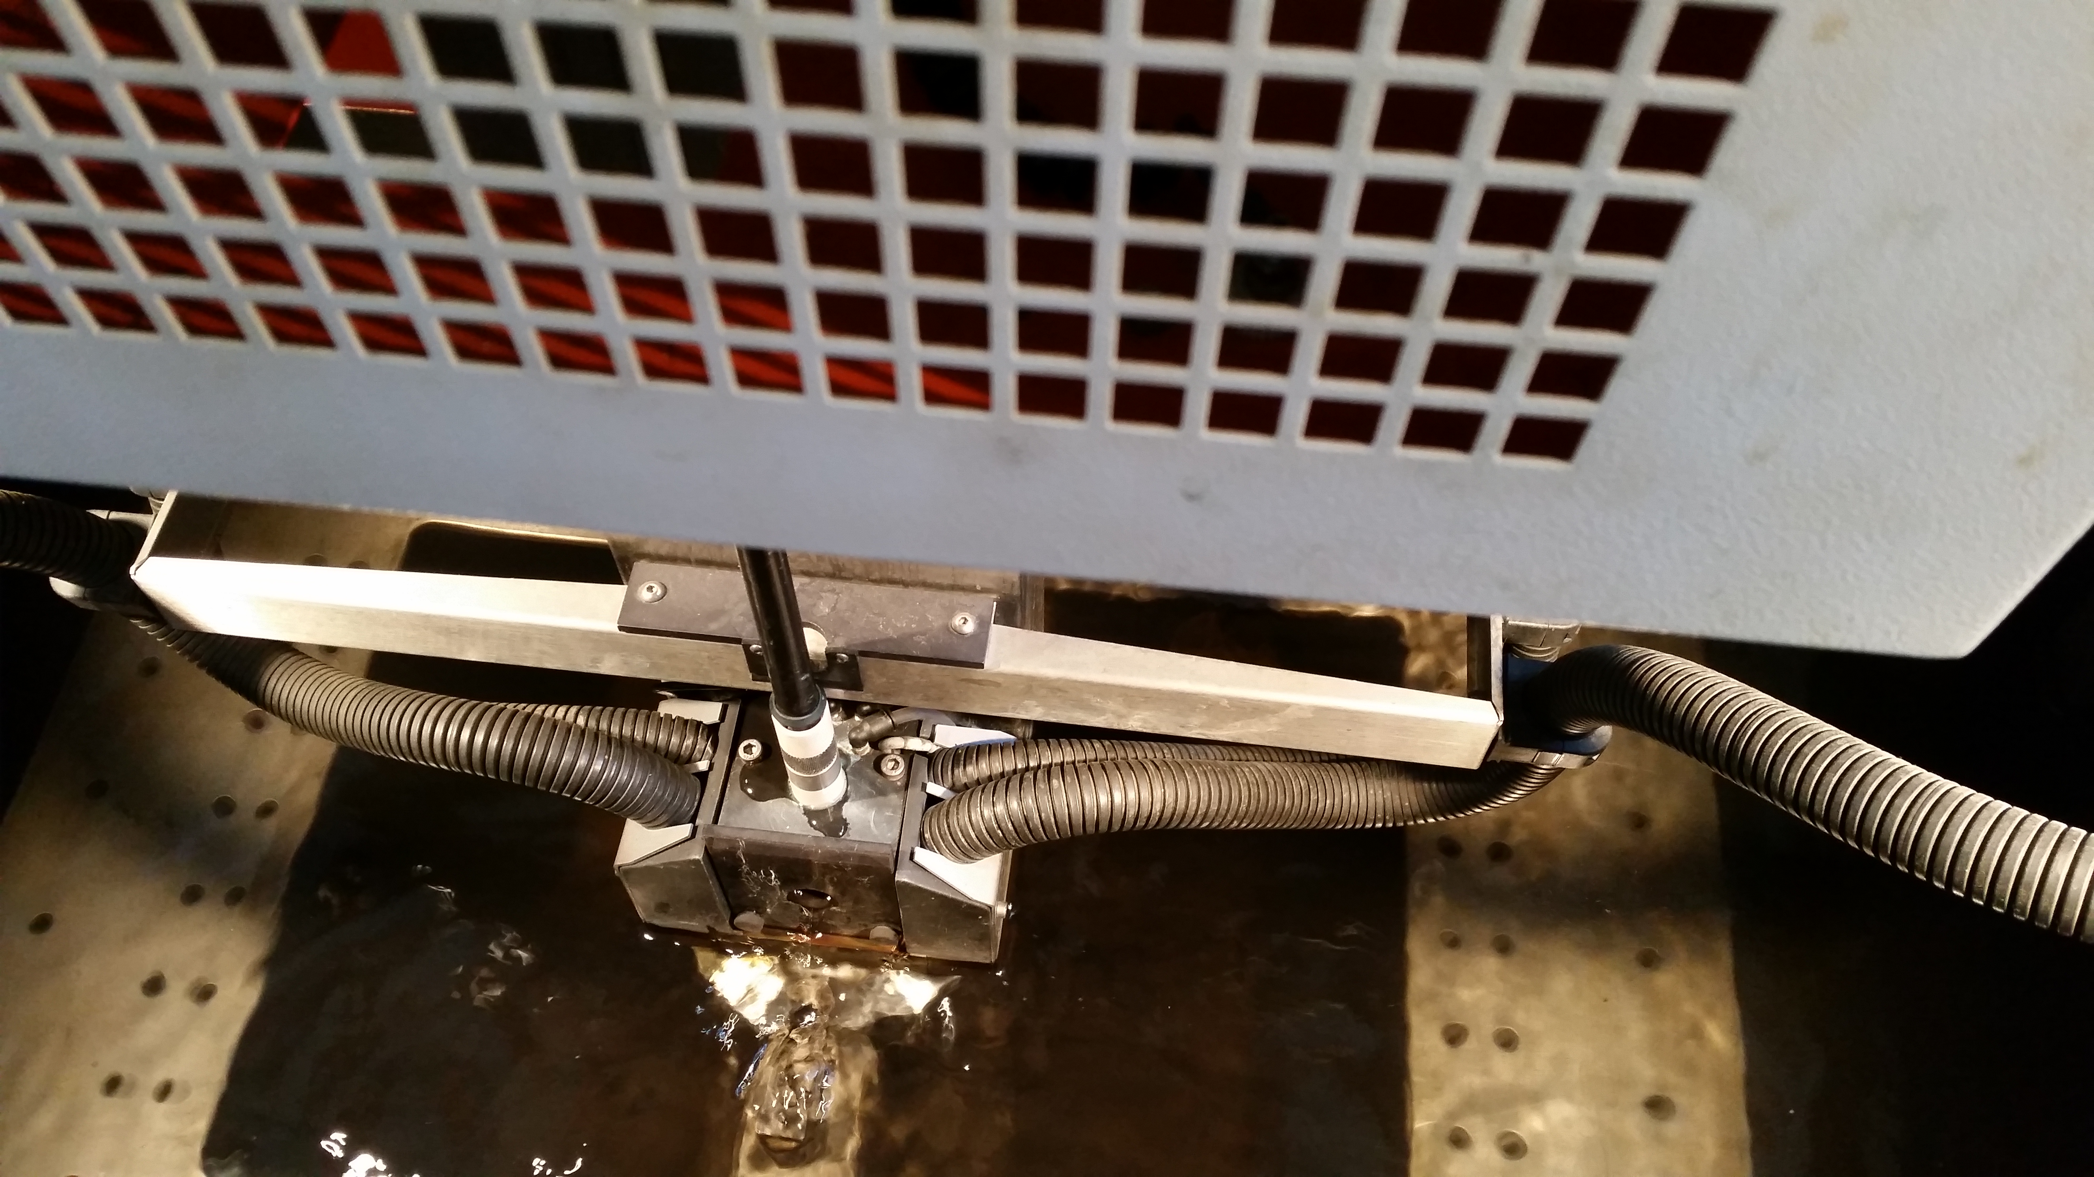

*(CNC Wire Erosion)*

* 1. **PRESS WORK**

I saw two types press machine in SAGE. One of them is very old and they didn’t use it.It was a mechanic control press machine. They generally use hyrolic one. When I ask them ‘ why u are use always this one’ , they told me this is more useful and comportable. I think press work is very important because they can any types of material with press work with using gages. At the this part of my report I want to give some information about press work and types of press work machines.

Press machines are used for shaping the material in a process of cold work and without chip removing. They have mainly two flat surfaces which get into each other and provide the shaping by the help of mechanic or hydrolic control. Two kinds of press machines are available in use;

* + 1. *Mechanical Control Press Machines*

Main part of this kind of press machines is the steel-made body and it has the control parts of the straight movement axle. The straight movement axle that moves forward and backward by the help of sliding bars, presses the workpiece between a mould and an active drill. Clutch arm transmits the circular motion to the axle. Press machines take the name according to the shape of the body that adjusted for the work and the control system of the movement axle. Generally the way of forward and backward is limitted.

If the workpiece requires so many bending, the press machine that provides limitless movement of axle should be preferred. That is to say, free-motion press machines are better to use. In addition, this kind of press machines include frictional screw press.

* + 1. *Hydrolic Control Press Machines*

For this kind of press machines, the movement axle is tied on a piston that is located in an cylindirical part which tied to the main body. Metallic oil is used as the fuel of engine. By this way, a pushing force between 5000-15000 tons or more is obtained. Getting much more power, fuel is compressed into the cylinder by a pump that connected to a accumulator. Because of mechanical control press machines are not good at the result of the usage, hydrolic press machines with a great power supply, become more popular.

After cutting operation is finished, circular sheet steels are come to various press machines according to its size.

By the way, this moulds come from the foundry as the result of casting and shaping in the chip removing workshop by engine lathe.

Before applying first press, all circular sheet steels are sunk into a soapy-water mixture. This operation makes the sheet steel slippery and easy to shape when press work is applied. Press work causes heating of the material. So, after taking the shape, it is sunk to a kind of bathtub to both purify the workpiece from the soap and make it cooler.

After bathtub operation, workpieces are gone to the sensitive cutting machines for another smoothing process of their rough sides. The following process is drawing the bottom part. Sticking aluminium part to the bottom is being easier and stronger by existing rough surface.

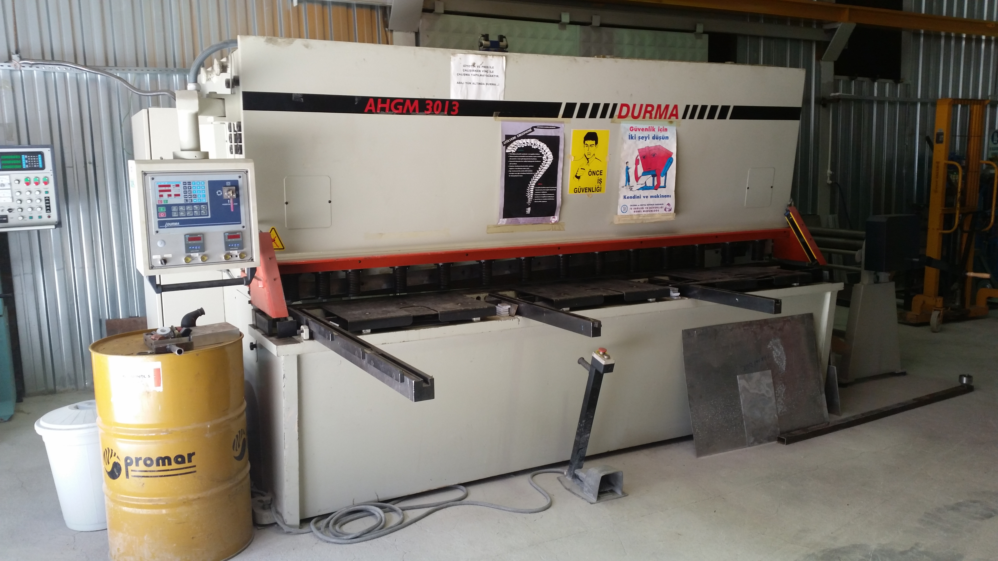

*(press machine)*

* 1. **WELDING**

Welding is a more important process in repairing and producing process. Sometimes you need produce huge material. You can’t produce it one time. You need produce small parts and you need to weld each other. When I do my practise engineeers send us a steel circle radius of 5 meters. We couldn’t produce this material on lathe and other machines. We divided this material and prepared their drawing. We produces material parts and after that we welded each other. Metal electrode method is used generally but if the material is small, they use oxyfuel gas welding. This part of my report I want to give some informaton about welding types.

Welding is a metal joining process inwhich coalescence is obtained by heat and/or pressure.In welding ,the metallurgical bond is accomplished by the attracting forces between atoms ,but these atoms can bond ,absorbed vapors and oxides must be eliminated from contacting surfaces .The number one enemy to welding is oxidation ,and consequently ,many welding processes are performed in a controlled environment or shielded by an inert atmosphere .If forge is applied between two smooth metal surfaces to be joined ,some crystals will crush through the surfaces and be contact .As more and more pressure is applied ,these areas is spread out and other contacts are made .The brittle oxide layer is broken and fragmented as the metal is deformed plastically .

Many welding processes have been developed .They differ widely in the manner that heat is applied and in the equipment used .Some of these process es require hammering,rolling ,or pressing to effect the weld ;others bring the metal to a fluid state and require no pressure .Processes that use pressure generally require bringing the surfaces of the metal to a temperature sufficient for cohesion to take place .This is usually a subfusion temperature ;however if the fusion temperature is reached ,the molten metal must be confined by surrounding solid metal .Most welds are made at fusion temperature and require the addition of weld metal in some form .Welds are also made by casting when metal is heated to a high temperature and poured into a cavity between the two pieces to be joined .

In any welding ,coalescence is improved by cleanliness of the surfaces to be welded.Surface oxides should be removed ,because they tend to become entrapped in the solidifying metal .Fluxes are often employed to remove oxides in fusible slags that float on the molten metal and the protect it from atmospheric contamination .In electric-arc welding,flux is coated on the electrode ,whereas in gas or forge welding a powder form is used .Since oxidation takes place rapidly at high temperature ,speed in welding is important.Perhaps one of the most significant variables controlling the amount of porosity is weld bead shape .Welds that are narrow and have high crown tend to trap hydrogen (main cause of porosity) ,because individual pores must rise a long distance before escaping to the surface .Welding position is another important factor :Overhead welds present five times more defects than flat welds .Storage time after cleaning and prior to welding effects the quality of the weld .Porosity susceptibility ,for example ,increases as the storage time of a cleaned workpiece is lengthened prior to welding .

* + 1. ***Arc Welding Process***

Arc welding is a process in which coalescence is obtained by heat produced from an electric arc between the work and an electrode .The electrode or filler metal is heated to a liquid state and deposited into the joint to make the weld .First ,contact is made between the electrode and the work to create an electric circuit .Then an arc is formed by separating the conductors.

The electric energy is coverted into intense heat in the arc ,which attains a temperature around 10.000 Fo (5500 Co) .

Either direct or alternating current can be used for arc welding ,direct current (dc) being preferred for most purposes .A dc welder is simply a motor generator set of constant energy type (constant potential may be used also)having the necessary characteristics to produce a stable arc .These shouldn’t be too great a current surge when the short circuit is made ,and the machine should compensate to some extent for varying lengths of the arc .

Metal Electrode Welding

Shortly after the development of the metal electrode welding ,it was discovered that a metal electrode with the proper current characteristics could be melted to supply the necessary weld metal .An arc is started by striking the work with an electrode and quickly raising it a short distance .New powdered-metal electrode designs involve a drag technique where the coated electrode rides lightly on the work .In both ,the electrode end is melted by the intense heat .Most of the heat is transferred accros the arc in the form of small globules to a molten pool .A small amount of metal vaporized and lost .Some globules are deposited beside the weld as spatter .The arc is maintaned uniformly moving the electrode along the work at a rate that compensates for metal that has been melted and transferred to the solid weld .At the same time ,the electrode is gradually moved along the joint .welding speed and the ease of welding with a-c and d-c welders are similar .However ,on heavy plate using large-diameter rods ,a-c welding is faster .direct current machine is used with all types of carbon and metal electrodes ,because polarity can be changed to suit the electrode .Most a-c welders the alternating current is constantly reversing with every cycle ,and electrodes have to be selected to operate on both polarities .Alternating-current welders operate at slightly higher voltages ,hence the danger of shock to the operator is increased .

Electrodes : There are three types of electrodes ;bare ,fluxed ,and heavy coated .Bare electrodes ,normally used with straight polarity ,are used in welding wrought iron and low- or medium-carbon steel .Welds are improved by applying a light coating of flux on the rods with a dusting or washing process .

In the ordinary arc with bare wire the deposited metal is affected by the oxygen and nitrogen in the air.This causes undesirable oxides and nitrides to be formed in the weld metal.The effect of heavy coatings on the electrodes provide a gas shield around the arc to eliminate such conditions and covers the weld metal with a protective slag coating that prevents oxidation of the surface metal during cooling .

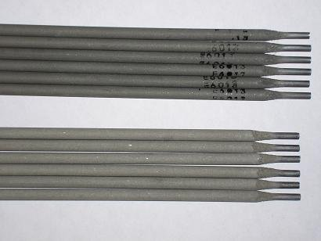

*(electrode)*

Electrode Coating

Electrodes coated with slagging or fluxing materials are necessary in welding alloys and nonferrous metals .Some of the elements in these alloys are stable and are lost if there is no protection against oxidation .Heavy coatings permit the use of larger welding rods ,stronger current ,polarity variation ,and higher welding speed. In summary, electrode coatings perform the following functions; provide a protecting atmosphere, provide slag of suitable characteristics to protect the molten metal, facilitate overhead and position welding, stabilize the arc, add alloying elements to the weld metal, perform metallurgical refining operations, reduce spatter of weld metal, increase deposition efficiency, remove oxides and impurities, influence the depth of arc penetration, influence the shape of the bead, and slow down the cooling rate of the weld .

Coating compositions are classified as organic and inorganic, and sometimes a combination of the two is used .Inorganic coatings are further subdivided into flux compounds and slag-forming compounds .The term “contact electrode “is given to electrodes having a thick coating with a high metal powder content .Most electrodes have an automatic striking orself-igniting characteristic because of the iron in the coating. By additing metal powder to the coating and increasing its thickness, the deposition rate is increased. Some of the principal coating constituents are;

1. Slag-forming constituents .SiO2, MnO2 ,and FeO, Al2O3 is sometimes used but it makes the arc less stable .
2. Constituents to improve arc characteristics .Na2O, CaO, MgO, and TiO2 .
3. Deoxidizing constituents .Graphite, aliminum and wood flour .
4. Binding material .Sodium silicate, potassium silicate, and aspestos .
5. Alloying constituents to improve strength of weld .Vanadium, cesium, cobald, molybdenum, aliminum, zirconium, chromium, nickel, manganese, and tungsten .

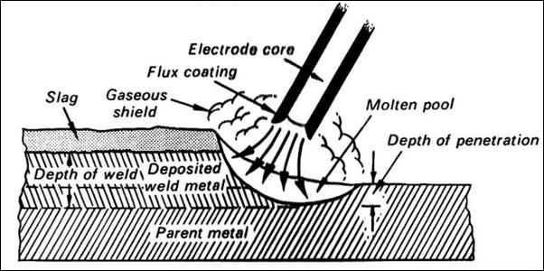

*( welding )*

Submerged –Arc Welding

This process is so named because the metal arc is shielded by a blanket of granular, fusible flux during the welding .Aside from this feature ,its operation is similar to the other automatic arc-welding methods .A bare electrode is fed through the welding head into the granular material .This material is laid along the seam to be welded and the entire welding action takas place beneath it .The arc is started by striking beneath the flux on the work or by initially placing some conductive medium ,such as steel wool, beneath the electrode.

The intense heat of the arc immediately produces a pool of molten metal in the joint and melts a portion of the granular flux .This material floats on top, forming a blanket that eliminates spatter losses and protect the welded joint from oxidation .Upon cooling the fused slag solidifies and is easily removed .Granular material not fused is recycled and used again.

This process is limited to flat welding ,although welds can be made on a slight slope or on circumferencial joints .It is advisable to use a backing strip of steel ,copper ,or some refractory material on the joint to avoid losing some of the molten metal .The process uses strong current (300 – 4000 A ),which permits a high rate of metal transfer and welding speeds. Deep penetration is obtained and most commercial-thickness metal plates are welded with one pass .As a result ,thin plates are welded without penetration ,whereas a small vee is required on others .Most submerged-arc welding is done on low-carbon and alloy steels ,but it may be used on the non ferrous metals .

* + 1. ***Oxy-fuel Gas Welding Process***

Oxyfuel gas welding (OGW) includes all the process in which a combination of gases is used to obtain a hot flame .Acetylene ,natural gas ,and hydrogen in combination with oxygen are the most common blends .Oxygen is produced by both electrolysis and liquification of air .electrolysis seperates water into hydrogen and oxygen by passing and electric current through it .Most commercial oxygen is made by liquefying air and seperating the oxygen from the nitrogen .It is stored in steel cylinders at a pressure of 2000 psi (14 MPa).

Oxyacetylene Welding

This is the most common of all OGW process .An oxyacetilene weld is produced by heating the parts with a flame that reaches temperatures of 6300 Fo (3500 Co) and with or without or without the use of a filler metal .the flame is obtained from the combustion of oxygen and acetylene .Most often the joint is heated to state of fusion and ,as a rule ,no pressure is used.

Acetylene gas ( C2H2 ) is obtained by dropping lumps of calcium carbide in water .The gas bubbles through the water ,and any precipitate is slaked lime .The reaction that takes place in an acetylene generator is ;

CaC2 + 2H2O Ca (OH)2 + C2H2

This gas is not stored safely at pressures higher than 15 Psi (0.1 MPa) ,so it is stored with acetone .Acetylene cylinders are filled with a porous filler saturated with acetone in which the acetylene gas can be compressed .

Advantages and uses of oxyacetilene welding are numereous .The equipment is comparatively inexpensive and requires little maintenance .It is portable and can be used with equal facility in the field and in the factory .With proper technique partically all metals canbe welded and the equipment used for welding as well as for cutting .

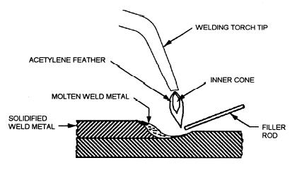

*(oxfuel gas welding)*

* + 1. ***Gas Tungsten Arc Welding***

[Gas tungsten arc welding](http://en.wikipedia.org/wiki/Gas_tungsten_arc_welding) (GTAW), or tungsten inert gas (TIG) welding, is a manual welding process that uses a non-consumable electrode made of [tungsten](http://en.wikipedia.org/wiki/Tungsten), an inert or semi-inert gas mixture, and a separate filler material. Especially useful for welding thin materials, this method is characterized by a stable arc and high quality welds, but it requires significant operator skill and can only be accomplished at relatively low speeds. It can be used on nearly all weldable metals, though it is most often applied to [stainless steel](http://en.wikipedia.org/wiki/Stainless_steel) and light metals. It is often used when quality welds are extremely important, such as in [bicycle](http://en.wikipedia.org/wiki/Bicycle), aircraft and naval applications. A related process, [plasma arc welding](http://en.wikipedia.org/wiki/Plasma_arc_welding), also uses a tungsten electrode but uses plasma gas to make the arc. The arc is more concentrated than the GTAW arc, making transverse control more critical and thus generally restricting the technique to a mechanized process. Because of its stable current, the method can be used on a wider range of material thicknesses than can the GTAW process, and furthermore, it is much faster. It can be applied to all of the same materials as GTAW except [magnesium](http://en.wikipedia.org/wiki/Magnesium), and automated welding of stainless steel is one important application of the process. A variation of the process is [plasma cutting](http://en.wikipedia.org/wiki/Plasma_cutting), an efficient steel cutting process.

[Submerged arc welding](http://en.wikipedia.org/wiki/Submerged_arc_welding) (SAW) is a high-productivity welding method in which the arc is struck beneath a covering layer of flux. This increases arc quality, since contaminants in the atmosphere are blocked by the flux. The slag that forms on the weld generally comes off by itself, and combined with the use of a continuous wire feed, the weld deposition rate is high. Working conditions are much improved over other arc welding processes, since the flux hides the arc and no smoke is produced. The process is commonly used in industry, especially for large products. Other arc welding processes include [atomic hydrogen welding](http://en.wikipedia.org/wiki/Atomic_hydrogen_welding), [carbon arc welding](http://en.wikipedia.org/wiki/Carbon_arc_welding), [electro slag welding](http://en.wikipedia.org/wiki/Electroslag_welding), [electro gas welding](http://en.wikipedia.org/wiki/Electrogas_welding), and [stud arc welding](http://en.wikipedia.org/wiki/Stud_arc_welding).

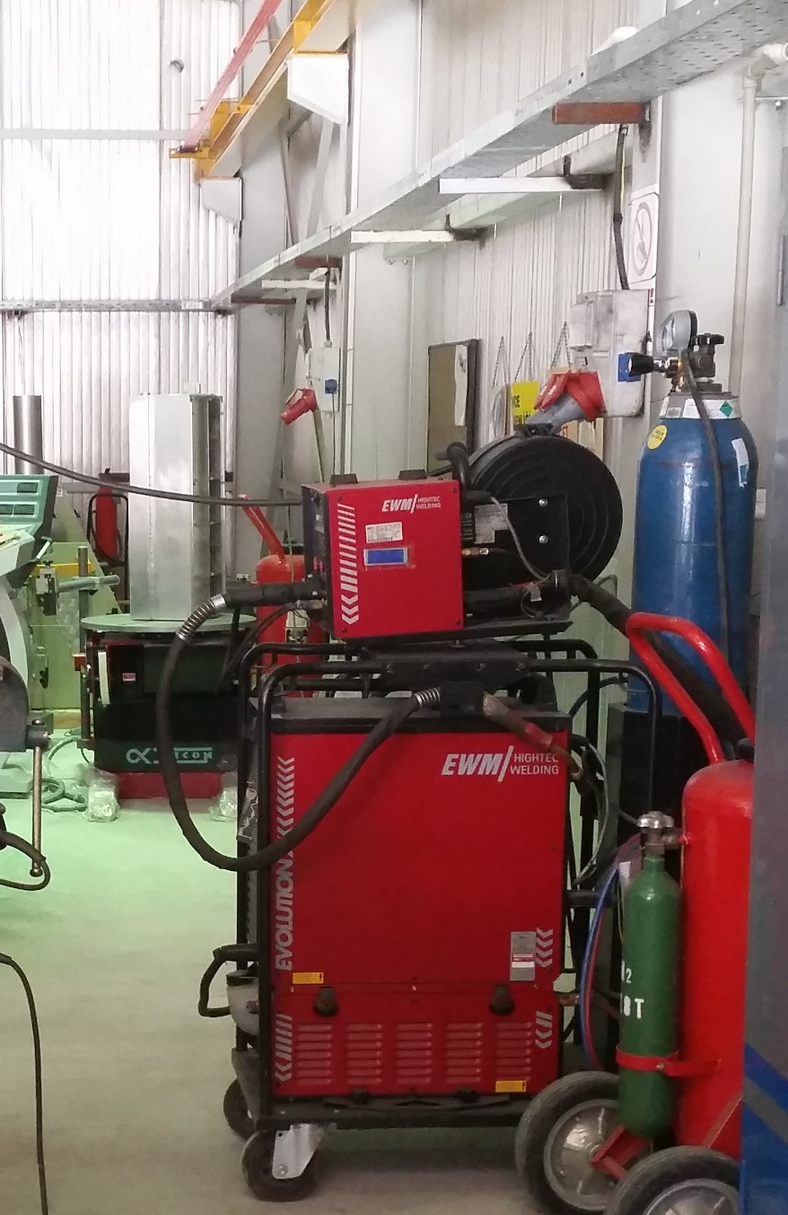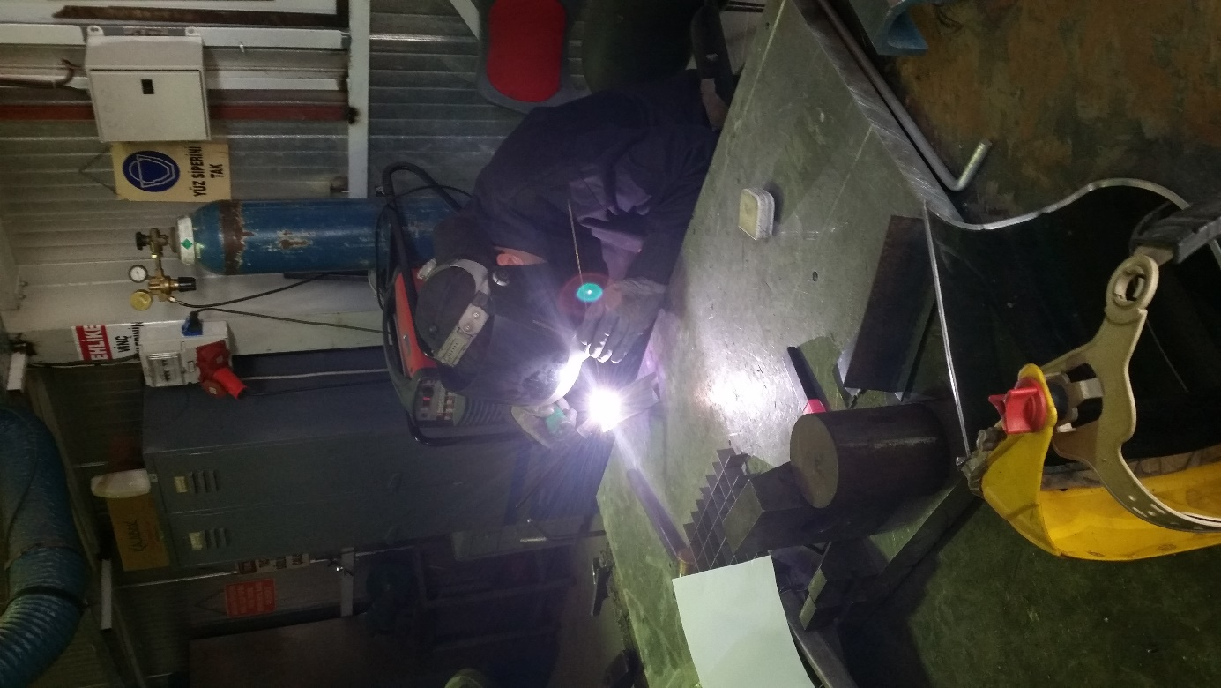

* + 1. ***Solid State Welding Process***

Solid state derives its name from solid state physics :the scence of the crystaline solid .In solid-state welding (SSW) processes ,such as co-extrusion welding ,hot pressure welding ,roll welding ,and those explained in this section ,metals do not melt .Adhesion is produced by metallic bonding of energized crystals .Normally the size of fragments trasferred between the parts grows until they become a continuous layer of plasticized metal ,but no evidence of a molten state is ever present .

Cold Welding :

Cold welding is a method of joining metals at room temperature by the application of pressure alone .The pressure applied causes the surface metals to flow ,producing the weld .It is a solid-state bonding process in which no heat is supplied from an external source .Butt welds of wire and rods are made by clamping the ends in special dies and bringing them together under a load sufficient to produce plastic flow at the joint .Before a weld is made ,the surfaces or parts to be joined must be wire-brushed throughtly at a surface speed around 15 m/s the remove oxide films on the surface .Other methods of cleaning seem to be unsatisfactory .In making a weld the pressure is applied over a narrow area so that the metal can flow away from the weld on both sides .It is applied either by impact or with a slow squeezing action ;both methods are equally effective .Ring welds ,continuous-seam welds and spot welds can be made .Spot welds are rectangular in shape and are approximately t by 5t in area ,where t represent the metal thickness .This method of welding is used primarily with aliminum and copper .Lead ,nickel ,zinc ,and Monel can also be joined by cold pressure .

* 1. **CASTING**

Casting is a basic forming process in which molten material (which is usually a metal) is poured into a mold which is prepared beforehand and let it solidify there to give the desired shape. One of the most important concepts in casting is shrinkage. Enough material should be fed by suitable means into the mold and cracks due to shrinkage should be avoided. Otherwise defects, which decrease the expected strength values, may occur. Casting is extremely important as it allows the production of intricate, difficult-to-shape geometries that cannot be manufactured by other processes, in a single step with appreciable accuracy.

### **Basic Requirements of Casting Processes**

1. A mold cavity, having the desired shape and size, must be produced with due allowance for shrinkage of the solidifying geometrical feature desired in the finished casting must exist in the cavity. Consequently , the mold material must be able to reproduce the desired detail and also have a refractory character so that it will not contaminate the molten material that it will contain.
2. A melting process must be capable of providing molten material not only at the proper temperature, but also in the desired quantity, with acceptable quality, and within a reasonable cost.
3. A pouring technique must be devised to introduce the molten metal into the mold. Provision should be made for the escape of all air or gases present in the cavity prior to pouring, as well as those generated by the introduction of the hot metal. The molten material is then free to fill the cavity, producing a high-quality casting that is fully dense and free of defects.
4. The solidification process should be properly designed and controlled. Castings should be designed so that solidification and solidification shrinkage can occur without producing internal porosity or voids. In addition, the molds should not provide excessive restraint to the shrinkage the accompanies cooling. If they do, the casting may crack when it is still hot and its strength is low.
5. It must be possible to remove the casting from the mold. With single-use molds that are broken apart and destroyed after each casting, there is no serious difficulty. With multiple-use molds, however, the removal of a complex-shaped casting may present a major design problem.
6. After the casting is removed from the mold, various cleaning, finishing and inspection operations may be required.

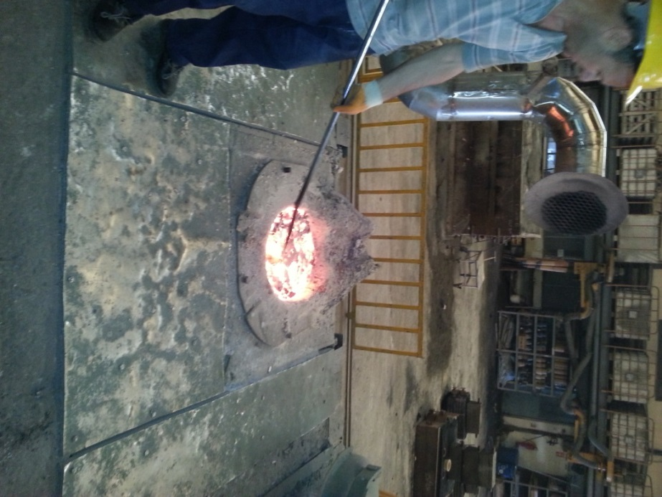

1. **CONCLUSION**

In this practice I saw many different machines . I saw and learned application of my theoretical knowledge . I moved with engineers and I examined their worklife and I felt what they feel in bad work conditions. I chatted with them and I listened their experiences and some very important things which is accepted by them . I learnt that what difference an engineer from a technician is and how engineers work themselves or all together.

In SAGE, I saw that how a factory runs. How does manufacturing continue and what are the responsibilities of a worker ,an engineer, a manager, a cheff etc. How an engineer improve himself or herself. And also I saw that connection between people , between engineers and workers .How does people in the factory communicate between each other etc...

In SAGE, managers try to improve their skills with joining some useful educational programs. And of course the educated people try to give information to the others what they have learned at the courses.

This experience taught me that besides the practical knowledge, theoretical knowledge supported practical information are much more important at engineering.

I saw many thing in my practice and they give me chance to think what I will do in my future job. I saw that mechanical engineering is not easy job. You always use your brain and solve problem. You don’t have too much time for resting.. but I will me mechanical engineering and this is my destiny.